Value and Momentum in Canadian Asset Classes: Identifying Return Drivers
By:
Ray Fang
Student Number: 1010264928
Rayf.fang@mail.utoronto.ca

Michael Yermolin
Student Number: 1009136383
Michael.yermolin@mail.utoronto.ca

Abstract
This paper investigates and assesses whether value and momentum-based characteristics can explain cross-sectional differences in next-month excess returns among Canadian equities. Using data on TSX 300 stocks from 2000 to 2024, we constructed monthly value and momentum signals based on dividend yield and 12–2-month cumulative returns. This accurately reflects each stocks book/inherent value relative to its market value and its recent price trends. Stocks are sorted into deciles each month, and long-short factor mimicking portfolios are formed by subtracting the average return of the lowest decile from the highest. These portfolios then produce monthly factor premia that summarize the aggregate behaviour of value and momentum-tilted investment strategies for Canadian assets. We used these constructed factors, stock level data, and an interaction term capturing potential nonlinearities, in a series of cross-sectional regressions to examine if and how these signals explain next month excess factor returns. To provide context, we began with a simple tilt-score regression used in the feasibility stage. This earlier specification relied on a composite measure of each asset’s value to momentum orientation. That model performed poorly. Its explanatory power was minimal (R² = 0.036), coefficient estimates were statistically insignificant, and the residual variance was large. Those results pointed to meaningful omitted variable bias, since the tilt-score combined information rather than isolating the separate value and momentum signals. Replacing the composite index with properly constructed value and momentum factors, following the methodology of our anchor paper, Asness, Moskowitz, and Pedersen (2013), Value and Momentum Everywhere, substantially improves statistical performance. Coefficients become statistically significant, standard errors fall, and root mean squared error declines. The interaction term increases explanatory power further and suggests that momentum behaves differently when value characteristics are extreme, consistent with nonlinear patterns documented in the international literature. Although the overall explanatory power of monthly factor returns remains modest, we observe a consistent and statistically significant negative relationship between value and momentum-based premia, indicating negative correlation. Economically, this shows us that value and momentum strategies hedge one another, and such signals can indicate preferable investment choices.

1. Introduction
Predicting asset returns is perhaps the most considerable and pursued endeavor in empirical finance. Momentum and value-based indicators are among many data derived financial metrics that explain systematic differences in average returns across equities. Our anchor paper, Asness, Moskowitz, and Pedersen (2013), Value and Momentum Everywhere, demonstrates that portfolios formed on these characteristics earn persistent and characterizable premia across international equity, currency, commodity, and bond markets. Despite extensive global evidence shown, comparatively little is mentioned about how these return patterns manifest within Canadian equities. This indicates an opportunity for analysis to determine if a similar relationship between value and momentum signals can be found solely within Canada’s unique market composition.
As such, this paper examines whether value and momentum signals can help predict next-month excess returns among stocks of the TSX 300 between 2000 and 2024. Using stock-level dividend-yield-based value signals and 12–2-month momentum signals, we sort our equities into deciles for each month and use the top-minus-bottom decile returns as averages to construct our value and momentum factors. This summarizes the aggregate performance of strategies based on their signal factors in the Canadian market. To capture potential nonlinear or interaction effects, we additionally include a multiplicative term between value and momentum factors, which we found substantially improved our model’s predictive power.
The empirical approach we employed progressed through two stages. We first constructed a simple linear regression using a “tilt-score” constructed in an earlier feasibility analysis, regressing next-month excess returns on a univariate measure of how heavily a portfolio leaned toward either value or momentum (standardized score across both). This preliminary specification produces weak explanatory power (R² ≈ 0.036) and statistically insignificant coefficients. This suggested that important sources of variation were omitted and that our model was not fitted to our data well enough. We then transitioned to a multi-variable cross-sectional regression using the factor-mimicking portfolio returns derived from our full data-processing pipeline. This step follows the empirical logic of Asness et al. (2013). We find this current model to be much more accurate in terms of explanatory power and is statistically significant for establishing a negative correlation for our factors similar to our anchor paper.
Finally, this study contributes to the literature by providing the first detailed examination of how value and momentum jointly behave in the Canadian market, and whether their well documented negative correlation also appears domestically. As well, understanding this relationship is of practical value to portfolio managers. This process displays how data-derived factor premia that move inversely can offer diversification benefits and highlight optimal investment choices.

2. The Context and Data
Our analysis focuses on a sample containing 213 distinct Canadian equities drawn from the TSX 300, covering the largest and most liquid firms in the Canadian market between January 2000 and December 2024. This a period covering multiple economic cycles and shocks. Our data is predisposed to an explanatory power that is comparatively lower than the anchor paper’s data. While they derive data from 40+ countries, we are restricting to Canada’s mineral and energy dominated market, which limits cross-sectional dispersion possibly affecting the strength of relative characteristic-based premia.
We construct two stock-level signals following basic formulations using our financial data. The value signal, for stocks, is measured using dividend yield, a proxy for relative cheapness that is widely available across Canadian firms. By skipping the most recent month, the signal more accurately reflects medium-term price trends and yields a cleaner measure of momentum. These signals are computed for each actively stock in each month.
To translate stock-level signals into factor-level quantities, equities are sorted into deciles (subsets of 1/10th the size of our sample) each month based on their value or momentum ranking. Consistent with Asness, Moskowitz, and Pedersen (2013), we construct factor-mimicking portfolios by taking the difference between the top and bottom deciles for each signal. This produces two different monthly factor premia denoted as: VAL_LH, capturing the performance of high-value versus low-value stocks, and MOM_LH, capturing the return spread between recent winners and losers. An interaction term, VAL×MOM, is also introduced by multiplying the two factor premia to capture potential nonlinear or conditional effects between characteristics.
The empirical analysis relies on two primary data files. The first, panel_mom_val_ca.csv, contains monthly stock-level price histories and signal values used to form the decile portfolios. The second, factors_ca.csv, provides the resulting factor premia, expressed as excess returns relative to the Canadian risk-free rate from the canadariskfreedaily.csv series. We decided to “derisk” our returns relative to each month to give values that more accurately reflect the priorities of portfolio managers in making decisions relative to the risk-free rate. All variables were appropriately cleaned where necessary to reduce the influence of outliers.
Together, this data allowed us to evaluate whether the factors developed from each stock’s value and momentum signals contain predictive information for next-month excess returns in Canada, and to compare the strength, stability, and interaction of these factors with patterns documented in international markets.

3. Regression Analysis

3.1 Simple Linear Regression
We begin by estimating a series of simple regressions designed to quantify the relationship between the value and momentum factor premia. The first specification regresses the value premium on a constant, and the second regresses the momentum premium on a constant. These models estimate the unconditional means of each factor, giving us a benchmark to regress over. The average monthly value premium is approximately 0.09% with a standard deviation of 4.19%, while the average momentum premium is roughly 0.68% with a substantially higher standard deviation of 10.58%. These summary patterns already indicate that momentum is much more volatile and yielding higher premia than value in Canada.
To assess whether the two premia move tangent to each other, we estimate the following specifications:
$$val_{lh}=a+bmom_{lh}+u$$
$$mom_{lh}=a+bval_{lh}+u$$
In both regressions, the slope coefficient is negative and statistically significant (p < 0.001), and both models produce an identical $R^{2}$of 0.084. The estimated correlation between the two factors is –0.2899, and each explains a similar share of the other’s variation. These results indicate a moderate but statistically significant negative relationship, like our anchor paper. Thus, when momentum premium is high, value premium tends to be low, and vice-versa.

3.2 Multiple Linear Regression
In our initial univariate linear regression we produced an extremely weak explanatory power. To avoid this we expanded our model to incorporate both respective factors explicitly as well as a joint regressor to capture their relationship. Such a decomposition eliminates (most of) the omitted variable bias and reduces estimator and residual variance. Our multiple linear regression takes the form:
$$mom_{lh}=a+b_{1}val_{lh}+b_{2}\left(val_{lh}×mom_{lh}\right)+u$$
(We did not include fixed year effects as an F-test showed that they are not jointly significant)
Thus, this regression accomplishes our goal of constructing a linear regression with significantly significant coefficients, a negative correlation as established in our anchor paper, and a comparatively low variance and bias while adequately modeling our factor premia.

4. Limitations of Results
Several limitations should be noted when interpreting our results. First, the analysis is restricted to the TSX 300s, which limits cross-sectional variation since the Canadian market is small and heavily concentrated in financials, energy, and materials. This naturally reduces statistical power compared to international studies such as Asness, Moskowitz, and Pedersen (2013).
Second, the regressions rely on a relatively short monthly time series (roughly 180–200 observations compared to the several thousand in our anchor paper), and factor premia at this frequency could be subject to noise. As a result, our modest $R^{2}$ value is to be expected
Third, the factor premia used in the regressions are constructed from idealized long–short portfolios that abstract from real-world occurrences. Other metrics such as liquidity, transaction costs, and short-selling constraints must be considered in real world applications. This means the results describe theoretical strategy performance rather than immediately implementable portfolio outcomes.
Overall, these limitations affect the precision but not the general direction and conclusivity of the results. The main findings should be understood as an accurate characterization of Canadian factor dynamics within these constraints.

5. Conclusion
This paper examines whether value and momentum signals predict next-month excess returns in the Canadian equity market. Momentum consistently shows strong predictive power, while value displays weaker yet consistent effects. The initial tilt-score regression demonstrates that omitting key variables leads to statistical insignificance and inflated residual variance. Once value and momentum are explicitly included, coefficients become more precise, residual variance falls, and predictive accuracy improves. Our end results reinforce and conclude the anchor paper’s findings hold for Canadian stocks.

References
Asness, Moskowitz, and Pedersen (2013), Value and Momentum Everywhere

Table 1: Summary Statistics
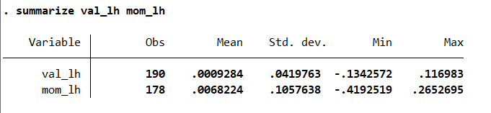

Table 2: Regression Results
Table 2.1: Regressing Value on Momentum (SIMPLE)
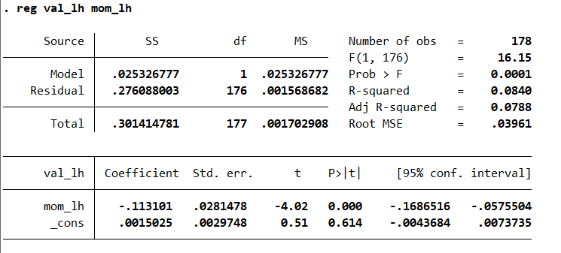
Table 2.2: Regressing Momentum on Value (SIMPLE)
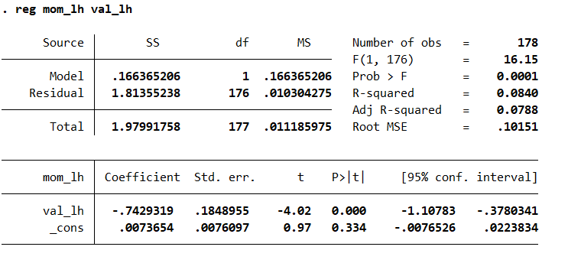

Table 2.3: Regressing Momentum on Value and Joint term (MULTI)
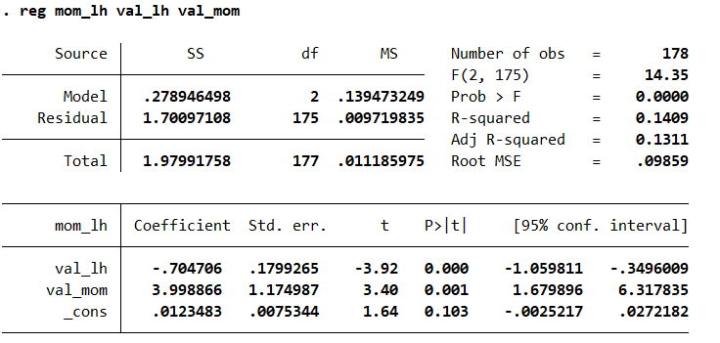
Table 2.4: Correlation between factors
